A000- AM,C-Taino-Mask-Maquetaurie Guayaba-Conch Shell-1000 CE

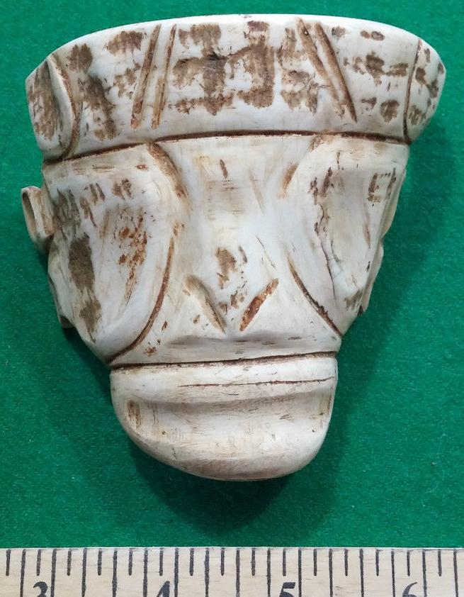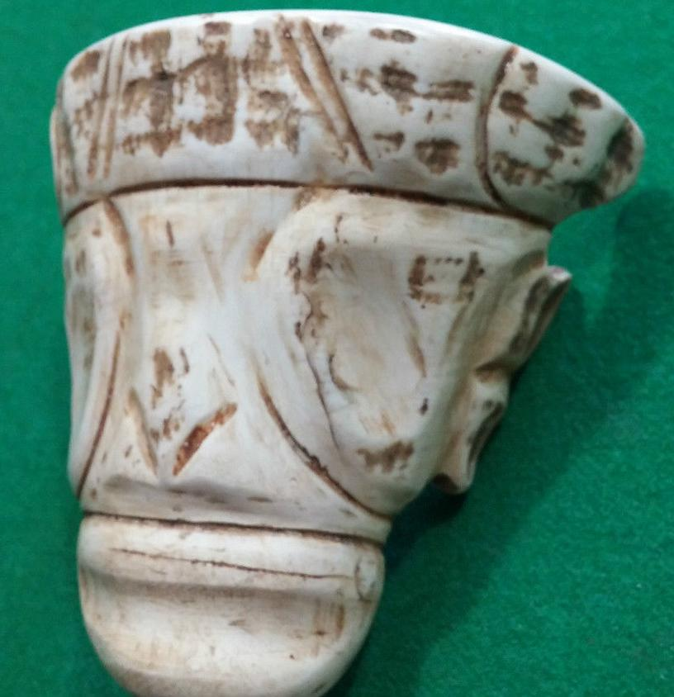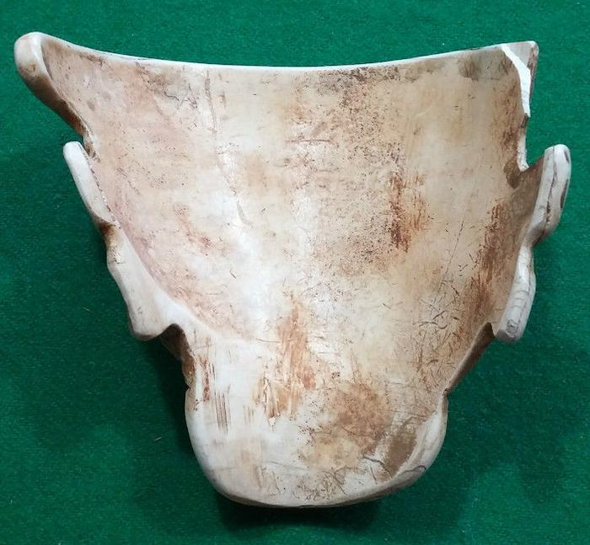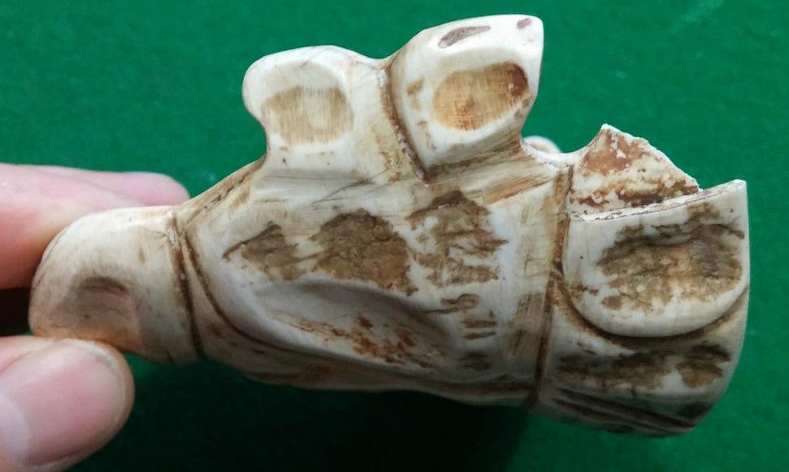

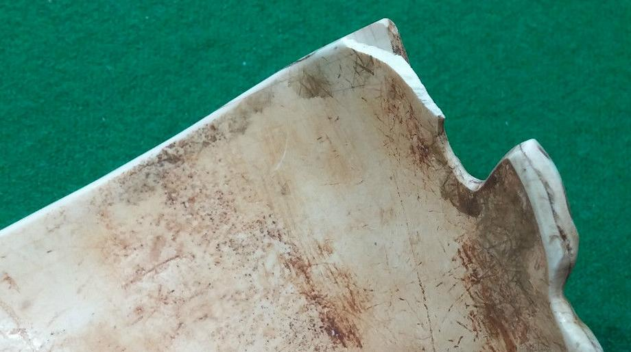

Figs. 1-5. AM,C-Taino-Mask-Maquetaurie Guayaba-Conch Shell-1000 CE

Taino conch shell maskette, depicting deity of the underworld, very rare.

Small piece missing on one side (top corner part of the ear)

Case No.: 18

**Accession No.**

**Formal Label:** AM,C-Taino-Mask-Maquetaurie Guayaba-Conch Shell-1000 CE

**Display Description:**

The Taino told Pané that the dead went to a place called Coaybayand that *Maquetaurie Guayaba* was Lord of this Dwelling Place of the Dead (Pané, 17-18.). *Maquetaurie Guayaba had* wide-open eyes because the place of the Dead was pitch dark and he had a mouth without lips hence his prominent teeth, one of *Maquetaurie Guayaba’s* distinguishing features.

According to Fray Pané, the Taino “believe there is a place where the dead go, which is called Coaybay, and it is located on one side of the island called Soraya. They say that the first person in Coaybay was one who was called *Maquetaurie Guayaba* (Makitori-Guarana.), who was the lord of the said Coayabay, house and dwelling place of the dead (Pané, ch. 12, 1999: 17-18). José Juan Arrom suggests *Maquetaurie* may be translated “without life” (ma being a negation and quetaurie “life”) and *Guayaba* may be translated as the fruit from the tropical tree *Psidium paniferum*. The Taino told Pané that the dead went to a place called Coaybay.The name Coaybay has been translated by Arrom as house and dwelling place of the dead or abode of the absent ones (Arrom 1989: 53).Coaybay was located on one side of an island called Soraya, which Martius translates as sunset and Arrom translates as "remote, inaccessible, unreal place” (Oliver 1998: 137). Therefore, there is a boundary separating Coaybay on one "side" of the island separating the world of the dead and the world of the living. The face of the first person in Coaybay was one who was called *Maquetaurie Guayaba*. Because he is the Lord of the Dark, such as in a cave or in a dark forest, he has wide eyes and because he needs no nourishment he has a mouth without lips but he is not smiling. Furthermore since he has no beginning and no end he has no navel that once connected him with a maternal origin, all of which signifies that *Maquetaurie Guayaba* is of the nether regions and death (Arrom in Pané 1999: 18, n. 80, n. 81).

**LC Classification: F1909**

**Date or Time Horizon: 1000 CE**

**Map:**

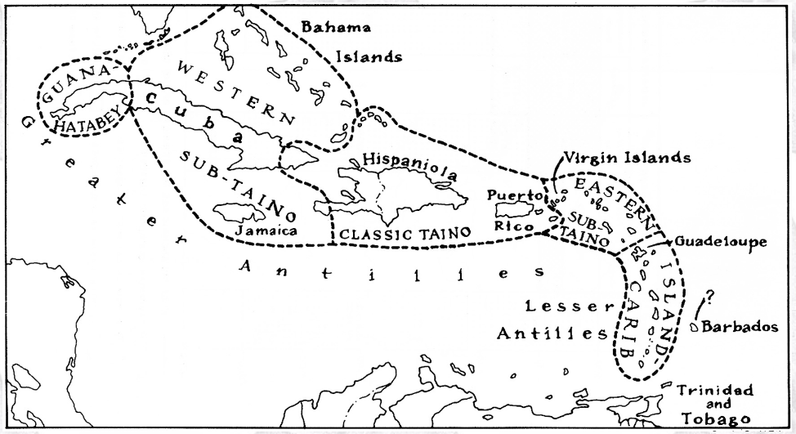

Caribbean c 1500 after http://www.latinamericanstudies.org/maps/Ciboney-Taino-Carib-

GPS coordinates:

**Cultural Affiliation:** Taino

**Medium:** conch shell

**Dimensions:**

**Weight:**

**Condition: original**

**Provenance:** from theDominican Republic

**Discussion:**

Pané was a Catalan a Hieronymite monk of the Order of St. Jerome. These hermit monks lived according to the Rule of Saint Augustine, which stresses chastity, poverty, obedience, worldly detachment, physical labor, fraternal charity, common prayer, fasting and abstinence. Saint Jerome, a fifth-century hermit and biblical scholar, formulated the rules of the order. In the eyes of the Spanish church hierarchy, Pané was a poor Hieronymite hermit, a Catalan peasant not of Castilian origins and was dismissed probably for these social reasons by the Spanish Dominican Bartolomé de Las Casas (ca. 1484– 18 July 1566) as a “simple man” with “limited faculties” (Pané p. 57), whose efforts, “amounted to nothing more than to say the Ave María and Pater Noster to the Indians, and some words about there being a God in heaven who was the creator of things, according to what he was able to teach them with abundant flaws and in a muddled way” (Pané p. 57). However derogatory Las Casas’ criticisms of Pané are, Pané’s *Account* is still the best source of information on the Taíno.

According to Pané there were twelve orders of spiritual entities that exemplified energies of a Supreme Being. These energies were encompassed in *cemís* which were intermediaries, much like Judaeo-Christian angels or Roman Catholic Saints. Since the repertoire of stone artifacts has now been relatively exposed to scientific scrutiny, each of the cemís spirits can be paired with its wood, stone, shell or textile material representation (Arrom 1975). The Taino also had a tripartite cosmos recorded by Pané which encompassed the sky, the earth and a lower world. These layered divisions are indicated on their most prominent artifact, the Three-pointed Sculpture.

**References:**

Alexander, Hartley Burr. "Latin-American." The Mythology of All Races. Vol. XI. New York: Cooper Square Publishers, 1964.  
Arrom, José Juan. Mitolog’a y Artes Prehispánicas de las Antillas. México: Siglo XXI Editores, 1989.  
Bartlett, John. Familiar Quotations. Boston: Little, Brown & Co., 1980.  
Benzoni, M. Girolamo. La Historia del Mundo Nuevo. Trans. Marisa Vannini de Gerulewicz. Caracas, Venezuela: Academia Nacional de la Historia, 1987.  
Bercht, Fatima; Brodsky, Estrellita ; Farmer, John Alan ; Taylor, Dicey, eds. Taino: Pre-Columbian Art and Culture from the Caribbean. New York: The Monacelli Press, 1997.  
Campbell, Joseph. Historical Atlas of World Mythology, v.2. The Way of the Seeded Earth, pt. 3. Mythologies of the primitive planters: the Middle and Southern Americas. New York: Harper & Row, 1989.  
Cassá, Roberto. Los Indios de las Antillas. Madrid: Editorial MAPFRE, S.A., 1992.  
Deren, Maya. Divine Horsemen: The Living Gods of Haiti. Kingston, New York: McPherson & Company, 1970.  
Gill, Sam D. Native American Religions: An Introduction. Belmont, California: Wadsworth Publishing Co., 1982.  
Gimbutas, Marija. The Language of the Goddess. New York: HarperCollins Publishers, 1989.  
Las Casas, Bartolome. A Short Account of the Destruction of the Indies. London: Penguin, 1992.  
Lopez-Baralt, Mercedes. El Mito Taino: Levi-Strauss en las Antillas. Rio Piedras, Puerto Rico: Ediciones Huracan, 1985.  
Oliver, Jose R. El Centro Ceremonial de Caguana, Puerto Rico. Oxford: Archaeopress, 1998.  
Pané. An Account of the Antiquities of the Indians. Ed. José Juan Arrom. Trans. Susan C. Griswold. Durham: Duke University Press, 1999.  
Rouse, Irving. The Tainos: Rise and Decline of the People Who Greeted Columbus. New Haven: Yale University Press, 1992.  
Stevens-Arroyo, Antonio M. Cave of the Jagua: The Mythological World of the Tainos. Albuquerque: University of New Mexico Press, 1988.  
Wilson, Samuel M., ed. The Indigenous People of the Caribbean. Gainesville: University Press of Florida, 1997.

